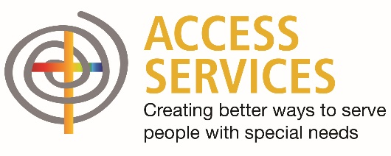

January 13, 2021

To Whom It May Concern:

(Name) works for Access Services in the role of a direct support professional. As you’ll see below, this position title is included in Phase 1A for vaccination administration.

Health care personnel as defined in Phase 1A includes:
- Physicians, nurses, nursing assistants, technicians, therapists, phlebotomists, emergency medical service personnel, direct support professionals (in-home and community-based services and adult day facilities), staff of long-term care facilities that have residents prioritized in 1A, staff in residential care providers serving children, pharmacists, clinical personnel in school-settings or correctional facilities, contractual staff working in but not employed by the health care facility, and people who are not involved in patient care who could be exposed to COVID-19 like dietary, environmental services, laundry, security, maintenance, facilities management, and other administrative staff as defined in the Interim Vaccination Plan.

We appreciate all you do to support our healthcare workers during this difficult time. If you have questions or would like additional information, please don’t hesitate to contact me.

Sincerely,

Janice Knowlton
Vice President of Autism and Intellectual Disabilities
Access Services
215-350-6793

