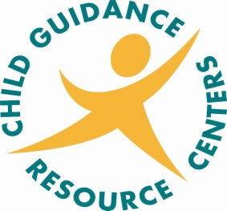

>>>>MAKE YOUR VOTE COUNT>>>>
Come visit us on National Voter Registration Day and take the mystery out of voting
Sponsored by the MAX Association and Child Guidance Resource Centers
Open to the public with a focus on individuals who may have difficulties voting on Election Day
Volunteers from the MAX Association and Child Guidance Resource Centers will be available to demonstrate how to use the voting machine
Assistance will be provided to complete the Voter Registration form.
General information about elections and County services will be provided.
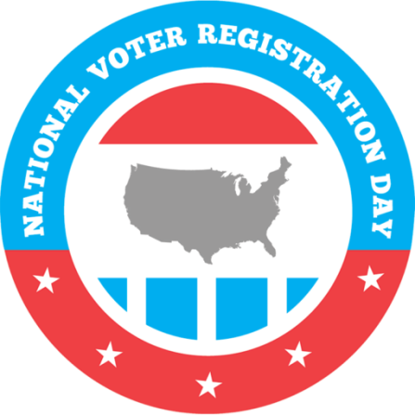
When: Tuesday April 5th, 2022

Where: Child Guidance Resource Centers
2000 Old West Chester Pike
Havertown, PA 19083
Time: 10:00 am – 1:00 pm

